What is a Queue?

Queue is a data structure that stores items in a First in / First Out manner. (FIFO)

Like a point sale system of a restaurant. Or a printer Queue.

Queue Operation

1. Create Queue
2. Enqueue

Insert a value into the queue.

1. Dequeue

Remove an element into a queue.

1. Peek
2. isEmpty
3. ifFull
4. deleteQueue

implementation:

1. Array
2. Linear Queue
3. Circular Queue
4. Linked List

Time and space Complexity of Linear Queue using Array:

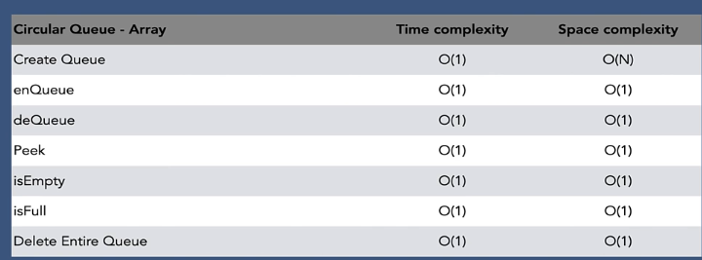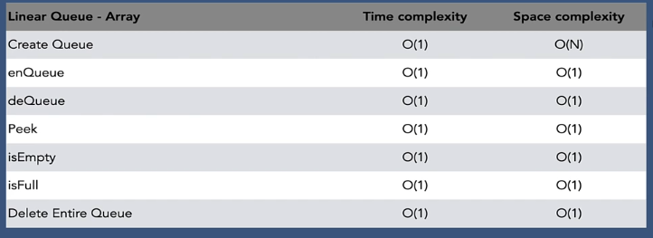

Time and space Complexity of Circular Queue using Array: